Exercise 4

- List the first and last name of all employees who draw less than or equal to $90000 and are not Programmers, Senior Programmers or Multimedia programmers.
SELECT f_name, l_name FROM employee_data WHERE salary <= 90000 AND title NOT LIKE '%Programmer%';
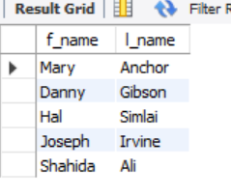
- What is displayed by the following statement?
Select l_name, f_name from employee_data where title not like ‘%Marketing%’ and age <30;
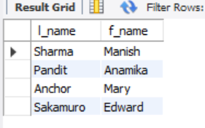
- List all ids and names of all employees between 32 and 40 years of age.
SELECT emp_id, f_name, l_name FROM employee_data WHERE age BETWEEN 32 AND 40;
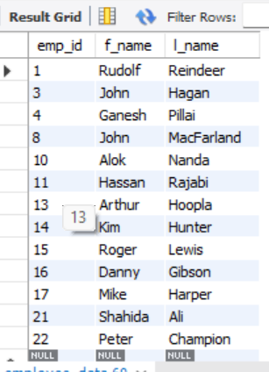
- Select names of all employees who are 32 years of age and are not programmers.
SELECT f_name, l_name FROM employee_data WHERE age = 32 AND title NOT LIKE '%Programmer%';
